**1970sdiskdrive**

1970s Disk Drive

**A Data Communication Historical Series**

**By Bob Pollard**

**A little Disk (disc) Drive trivia:**

Disk drives have evolved from the single 20-inch heavy platter (disc) contained in a fairly large cabinet that was capable of storing approximately 24 megabits. Compare this to the disk drives of today that may measure about six inches square and one inch thick, and they can be a stand alone unit that sits on a desk top in a 9 to 10 inch square by three to four inch high housing or can be installed in the computer mainframe. And, of course, the disk storage capacity, speed and size have changed for the better. There are magnetic coated read and write disks and non-magnetic laser (optical) read or write disks. The magnetic disks place a 1 or 0 on the surface by magnetizing a spot for a 1 bit or non-magnetizing for a 0 and the laser disks read peaks and valleys or color changes that have been recorded on the disk surface. Originally once a laser disk had been recorded it could not be changed and became a read only disk. New technology has created laser disks that can be used as read and write disks with changeable read/write capabilities. CD-ROM (Compact Disc-Read Only Memory) is normally a laser read disk.

A disk is a random access devise, unlike serial (sequential) tape drives, which means information, can be written or read randomly over the surface of the disk. All data is read or written on a track and sector bases controlled by a track and sector address. When writing to the disk any overflow data, larger than a sector, would be written to another sector(s) until the total record is recorded. This may consume many sectors, located on different tracks. Data sizes smaller than a sector would still cause the sector to be listed as full. Although, in some of the more sophisticated Disk Operating Systems and other programs of today different data (unrelated) can be stored together in a sector in order to fill the sector. Also the sector can be varied in length. Recording (writing) usually will not be performed on consecutive sectors because information is recorded in a scatter manner. This is caused by information being deleted or revised over time, which causes the empty (erased) sectors to be scattered around the disk. That’s why disk defragmenter programs are used to sort and place the empty and full sectors in an orderly sequence, which reduces the disk seek and latency time. Also, this defragmentation process reduces wasted disk space.

**Typical 1970’s Disk Drive:**

The following illustration provides a brief overview of a typical disk used in the 1970’s for secondary storage (memory overflow) or for history records. The disk pack (six discs) is approximately 12 inches in diameter and rotated at a speed of 2400-RPM (Revolutions per Minute). The average head(s) access time, to position a head at one of the 203 tracks per individual disc surface (2 sides), is approximately 60 milliseconds. This is called cylinder seek time. The entire disk pack must rotate to a point where the appropriate head is positioned over the desired individual disc surface for a read cycle or over the selected empty sector for writing (recording). This rotating time is called the average latency time, approximately a 12.5 millisecond average. The total storage capacity of these disk packs varied, depending on the device, from 5 to 10 million bytes. The disk pack is removable (portable) and could be stored in a carrying case for future use or historical records. The head assemblies retracted so the disk pack could be removed or installed.

[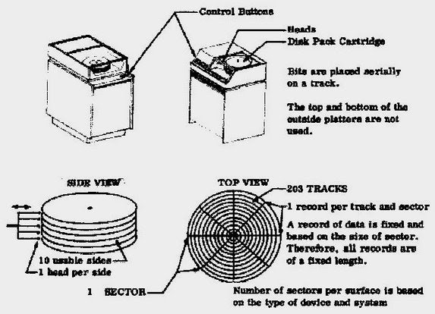](https://sites.google.com/site/mdprcp/1970sDiscDevice.tif?attredirects=0)

**Modern Disk Drives:**

Today there are many different types of disks, but only a few types are used for data communications, which includes the Floppy disk and the computer Hard Drives (magnetic coated disks). The laser (optical) disks, such as, CD-ROM (Compact Disc-Read Only Memory) and the similar CD with a Write or Rewriteable (recording) capability, along with the Digital Versatile Disk (DVD) all use the laser system for reading and writing and are not normally used for data communication, but may be used for manually transferring information. All of these disks are single platter (disc) devices.

Even though daily technological advances continue to upgrade the disk drive features and capabilities the basic concept remains the same. The widely used 1.44-megabyte Floppy disk drive that has been around for over 30 years (early 1970’s) uses a 3.5-inch diskette. At the time of their introduction they held more data than the standard 5.25-inch disk. The name floppy disk is used because the disk is flimsy or flexible. Here are some of the typical parameters for a floppy disk:135 tracks per inch

* 18 sectors per track
* 512 bytes per sector
* 360 rpm spin rate
* Head movement mechanism; stepper motor and worm gear

The low number of tracks and the fixed number of sectors per track are not a very efficient use of the disk surface. The construction of the disk, using a flexible disk, resulted in a magnetic coating that could not be used as efficiently as a hard non-flexible disk (hard drive). Although, later floppy disks introduced are more efficient and havel arger storage capacity. The floppy disk can be housed in a stand-alone device or installed as an internal CPU (Central Processing Unit) device.

The large capacity hard drives, non-flexible, used in many computers, personal and otherwise, have a much higher quality magnetic coating than the Floppy disk. The higher quality coating means that the disk read/write head can be significantly smaller than the one used in a floppy disk. The smaller head combined with an efficient head positioning mechanism, means that a disk drive can pack thousands of tracks per inch on the disk surface. Some hard drives also use a variable number of sectors per track to make the best use of disk space. All of these things combine to create a disk that holds a huge amount of data, typically between 10 and 120 gigabytes (billion bytes).

**Storing Data on the disk platters:**

Data is stored on the surface of a platter(s) in ‘sectors’ and ‘tracks’, much in the same manner as the original drum and large hard disk. Tracks are concentric circles, and sectors are individual parts on a track, as illustrated in the following picture, not to scale:

**As illustrated below the disk is divided into tracks (concentric rings) and sectors ( 1 sector-black) Not to scale**

[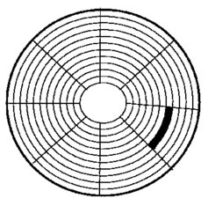](https://sites.google.com/site/mdprcp/Disclayout.tif?attredirects=0)

Tracks are individual rings and a sector is a section of a track. A sector will store a fixed number of bytes, for example: 256 or 512 bytes. Sectors are often grouped together into clusters, either by the disk drive electronics or by the operating system utilizing the hard drive. The number of tracks and sectors on each platter of the hard disk drive may vary in accordance to the technological design of the hard disk drive. The process of low-level formatting a drive establishes the tracks and sectors on the platter and the starting and ending points of each sector are written onto the platter. This process prepares the drive to hold blocks of bytes. High-level formatting then writes the file-storage structures, such as the file allocation table, into the sectors. This process prepares the drive to hold files.

In today’s world a typical desktop computer could have a hard disk with a capacity between 10 to 120 gigabytes, and in the future the maximum storage capacity will probably increase because of technological advances. Data is stored onto the disk in the form of files, which is a name for a collection of bytes. The data stored in the bytes might be ASCII code characters or other types of information representing a text file; or the instructions of a software application for the computer to execute; or the records of a data base; or the pixel colors for a GIF image. No matter what the bytes contain a file is simply a string of bytes. When a program running on the computer requests a file, the hard disk retrieves the information (bytes), one sector at a time in sequence, and sends the information to the CPU (Central Processing Unit).

There are few parameters or performance standards that could be used to measure the efficiency of a good hard disk drive, such as:

* Data transfer rate: The data transfer rate is the number of bytes per second that the disk drive can transfer to the CPU. Rates between 5 and 40 megabytes per second are common.
* Seek time (head positioning time): The seek time is the amount of time consumed between when the CPU requests a file and when the first byte of the file is transferred to the CPU. A seek time between 10 and 20 milliseconds is common.
* Another important parameter is the capacity of the drive, which is the number of bytes it can hold; presently between 10 and 120 gigabytes (billion bytes) is typical.
* Typically a hard drive spins at a rate of 7200 RPM (Revolutions per Minute).
* The hard disk platter (surface) can spin underneath the head at speeds up to 3,000 inches per second.